Step 1 : download java selenium library

[https://www.selenium.dev/downloads/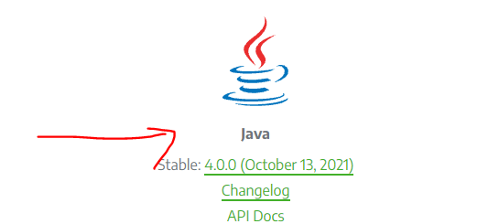](https://www.selenium.dev/downloads/#)

**Installing protractor**

Step 1: Go to command terminal and run code

npm install -g protractor

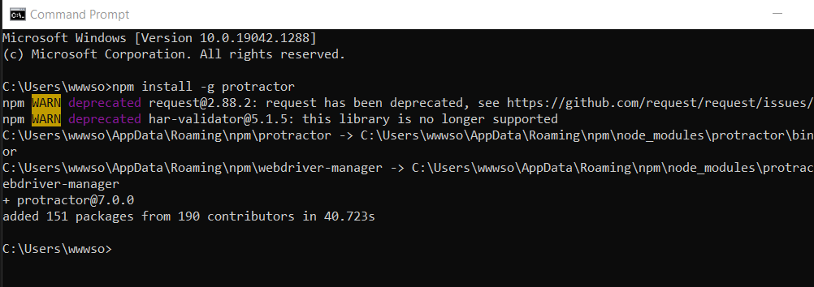

Step 2: Check if it is properly installed using the following command

protractor --version

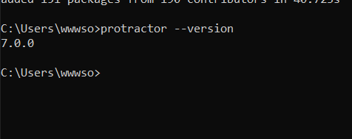

Step 3:

Run command webdriver-manager update

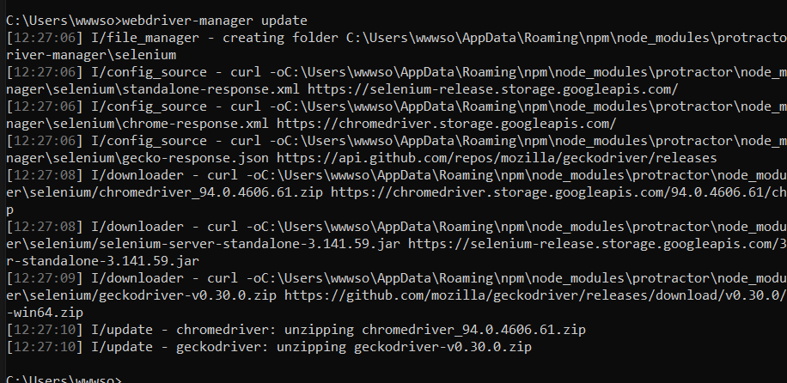

Step 4:run command webdriver-manager start

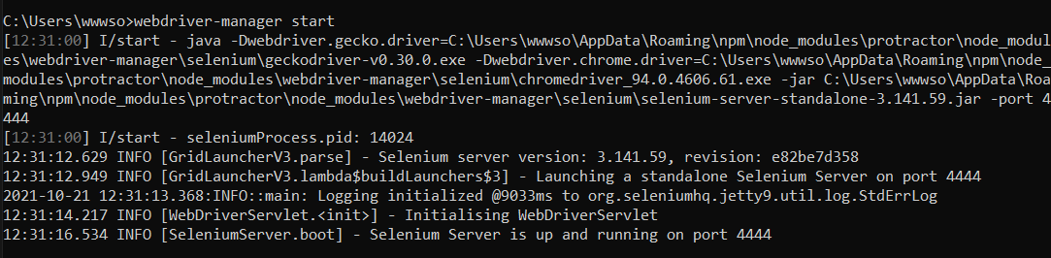

Open VS code

Step1: Create new folder protractor

Step2: Inside it create a folder Specs

Step3: Inside Specs create file spec.js and enter the below given code

describe('Protractor Demo', () => {

    it('Should navigate to Demo Page', () => {

        browser.get('https://material.angularjs.org/latest/getting-started');

        browser.getCurrentUrl().then((url) => {

            expect(url).toBe('https://material.angularjs.org/latest/getting-started');

        });

    });

});

Step 4: Inside protractor create a file confi.js and enter the below given code

exports.config = {

    framework: 'jasmine',

    specs: ['./Specs/spec.js'],

    directConnect: true,

}

In the terminal enter the command protractor confi.js